**TRINITY INTERNATIONAL SS & COLLEGE**

**Dillibazar Height, Kathmandu, Nepal**



**LAB WORK #1: SQL**

**(COMPUTER SCIENCE)**

**SUBMITTED BY: SUBMITTED TO:**

**NAME: Prashim Timsina**

**GRADE: XII (MA2)**

**DATE : [2023/09/15] DAYA RAM YADAV**

**Faculty of Computer Science**

**KATHMANDU, NEPAL**

**2023 Table of Contents**

S. No. Page No.

1. Table of Contents 1

2. Objectives 2

3. Theoretical Background 2

3.1 Historical Perspective 2

3.2 Core Components of SQL 2

3.1 Key Concepts in SQL 3

3.1 Significance in Today’s World 3

4. Work Done 5

5. Conclusion 15

Page: 1

**2. Objective**

The main objectives of the lab work are as follows:

1. To understand the concept of RDBMS.
2. To understand how to create a database.
3. To understand how to create a table.
4. To understand DDL commands (CREATE, ALTER, DROP)
5. To understand DML commands (INSERT, UPDATE, DELETE)
6. To understand DQL commands (SELECT)

**3. Theoretical Background**

Structured Query Language (SQL) is a powerful and versatile domain-specific language primarily designed for managing, manipulating, and querying relational databases. Since its inception in the 1970s, SQL has become a cornerstone in the field of data management and has played an integral role in the development of modern information systems. This comprehensive overview aims to provide a deeper understanding of SQL by exploring its history, core components, essential concepts, and its significance in today's data-driven world.

3.1. Historical Perspective:

SQL was developed in the early 1970s at IBM by Donald D. Chamberlin and Raymond F. Boyce as a response to the growing need for a standardized language to interact with relational databases. Initially known as SEQUEL (Structured English Query Language), it underwent several iterations and eventually became SQL. In 1986, the American National Standards Institute (ANSI) established SQL as an official standard, ensuring cross-vendor compatibility and driving its widespread adoption.

3.2. Core Components of SQL:

SQL comprises various components that collectively enable users to interact with relational databases effectively:

* Data Definition Language (DDL): DDL statements define and manage the structure of the database, including creating, altering, and deleting tables, indexes, and constraints.
* Data Manipulation Language (DML): DML statements are used to query, insert, update, and delete data within tables.

Page: 2

* Data Control Language (DCL): DCL statements manage user permissions and access control, allowing administrators to grant or revoke privileges on database objects.
* Transaction Control Language (TCL): TCL statements help maintain data integrity by managing transactions, enabling users to commit or roll back changes.
* Query Language: SQL's query language is at the heart of its functionality, providing a standardized way to retrieve data from relational databases using SELECT statements.

3.3. Key Concepts in SQL:

* Tables: In SQL, data is organized into tables, each consisting of rows and columns. Tables serve as the foundation for data storage and retrieval.
* Normalization: SQL databases are often designed using normalization principles to minimize redundancy and improve data integrity.
* Primary Keys: Primary keys are unique identifiers for each row in a table, ensuring data uniqueness and facilitating efficient data retrieval.
* Foreign Keys: Foreign keys establish relationships between tables, enforcing referential integrity and maintaining data consistency.
* Indexes: Indexes enhance query performance by providing quick access to specific data subsets.
* SQL Functions: SQL offers a wide range of built-in functions for data manipulation, aggregation, and transformation.
* Views: Views are virtual tables created by defining a query. They offer a simplified way to access complex data structures.
* Stored Procedures: SQL allows the creation of reusable, parameterized procedures, enhancing code modularity and security.

3.4. Significance in Today's World:

* SQL remains a foundational skill for professionals in data-related fields. Its importance stems from its role in:
* Data Management: SQL is essential for creating, maintaining, and querying relational databases, which are the backbone of most enterprise systems.
* Data Analysis: SQL is a vital tool for data analysts and scientists who use it to extract, transform, and analyze data to derive valuable insights.
* Business Intelligence: SQL forms the basis of business intelligence (BI) tools, enabling organizations to make data-driven decisions.

Page: 3

* Web Development: SQL is used in web development to interact with databases and dynamically generate web content.
* Data Security: SQL is instrumental in managing access control and ensuring data security in database systems.

Page: 4

**4. Work Done**

1. Database Practical Session -1
2. Create a database named ‘EMPLOYEE’.

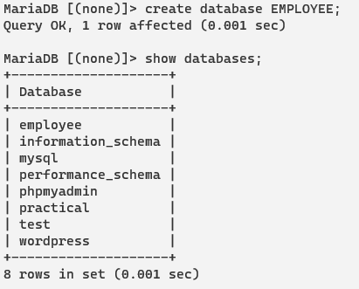

1. Get inside the database.



1. Create a table named ‘employee’ with following fields.

employee_id int primary key not null auto increment

employee_name varchar(100)

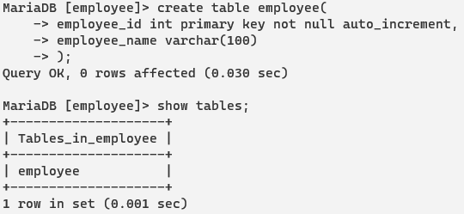

1. Delete the table.

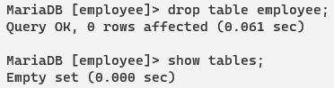

1. Know whether that deleted table exists or not.



1. Delete the database which you have created (student).



1. Know whether that deleted database exists or not.

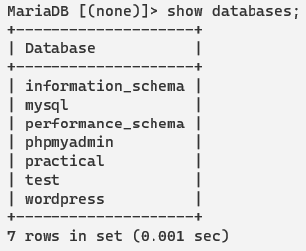

1. Database Practical Session -2
2. Create a database named ‘student’.



1. Create a table ‘student’ with following fields.

Student_id-------------integer not null primary key auto increment

Student_name---------varchar(100)

Student_address-------varchar(100)

Student_grade---------integer(int)

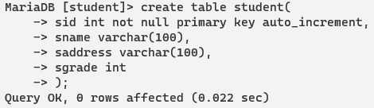

1. Insert any 6 records using ‘insert’ and ‘values’ command.

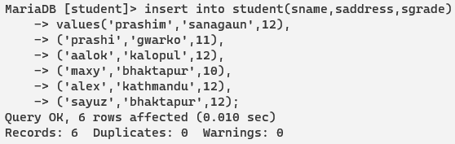

1. Display all the records of all fields.(Use select *).

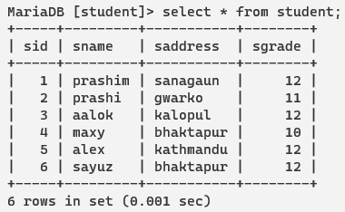

1. Display all the records of fields’ student_id and student_name.

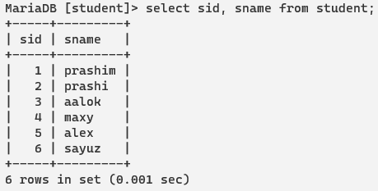

1. Display records of students whose name starts with letter ‘a’.

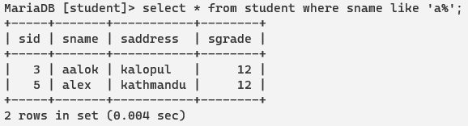

1. Display records of students whose name ends at letter ‘y’.

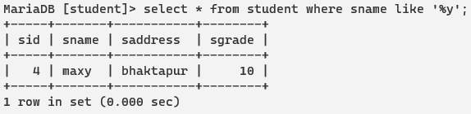

1. Display all the records of students whose grade is 12. Use ‘where’ command.

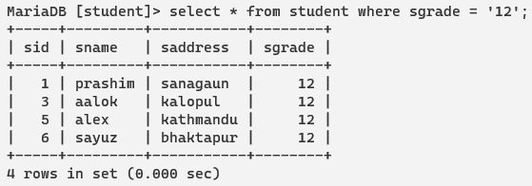

1. Display all the records of students whose grade is 12 and who are from address “Kathmandu”. Use ‘and’ operator.

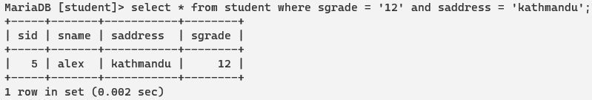

1. Update the student name with any other name who has id 1.

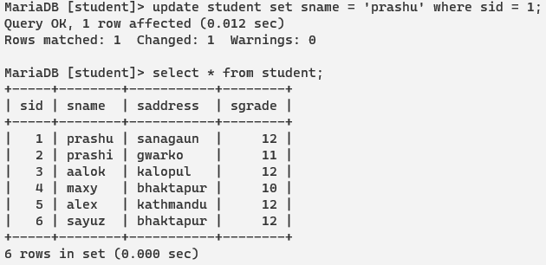

1. Delete the record of student whose id is 3.

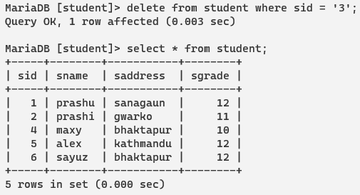

1. Display the records of students in sorted order using field ‘student_name’. Use ‘order by field name asc/desc’.

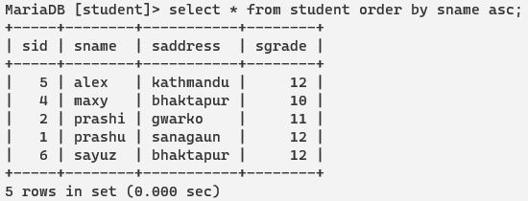

1. Alter the table with following fields.

Add one more field student_section---→varchar(100). [Use alter and add command]

Change the size of field student_address--→200 [Use alter and modify command]

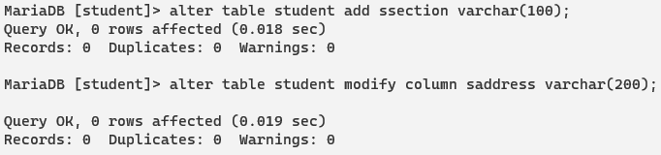

1. Database Practical Session -3
2. Create a database named ‘employees’.



1. Create a table ‘employee’ with following fields.

emp_id--------------→integer not null primary key auto increment

emp_name---------→varchar(100)

emp_position-------→varchar(100)

emp_salary----------→float

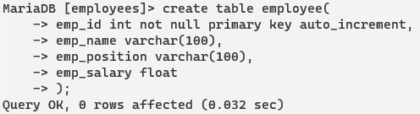

1. Insert any 6 records using ‘insert’ and ‘values’ command.

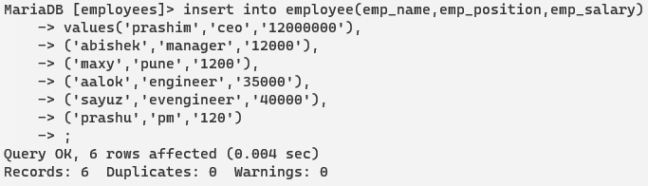

1. Display all the records of all fields.(Use select *)

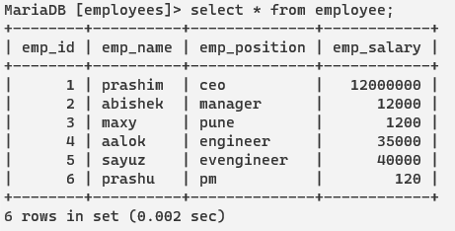

1. Display all the records of fields’ emp_id and emp_name.

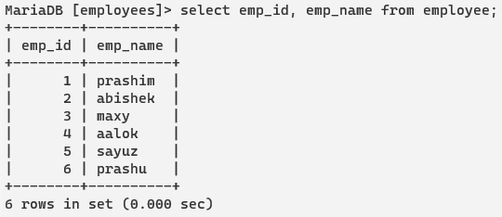

1. Display records of employees whose name starts with letter ‘ab’.

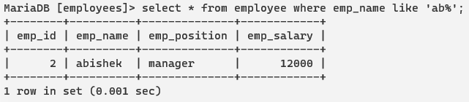

1. Display records of employees whose name ends at letter ‘y’ and starts from ‘b’.

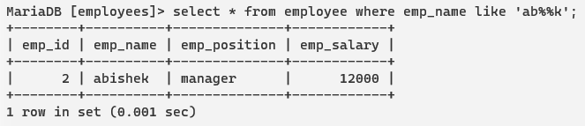

1. Display all the records of employees whose position is ‘engineer’.

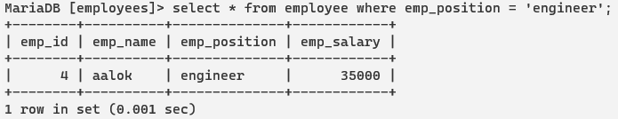

1. Display all the records of employees whose salary is in range 30000-45000.

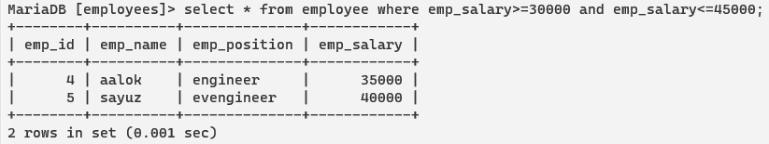

1. Update the employees name with any other name who has id 1.



1. Delete the record of employees whose id is 3.



1. Display the records of employees in sorted order. Use ‘order by field name asc/desc’.

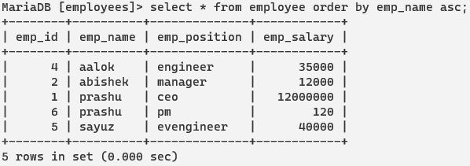

1. Alter the table with following fields.

Add one more field employees_address ---→varchar(100). [insert after name field]

Change the size of field employees _position--→200 [Use alter and modify command]

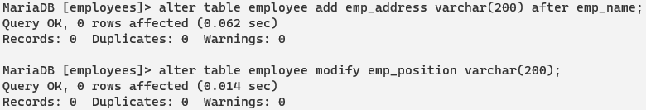

1. Find the maximum and minimum salary in database.

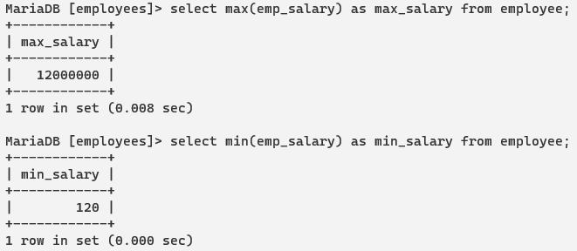

1. Find the average salary distribution in database.

[Note: Use both shell interface and graphical interface for these operations]

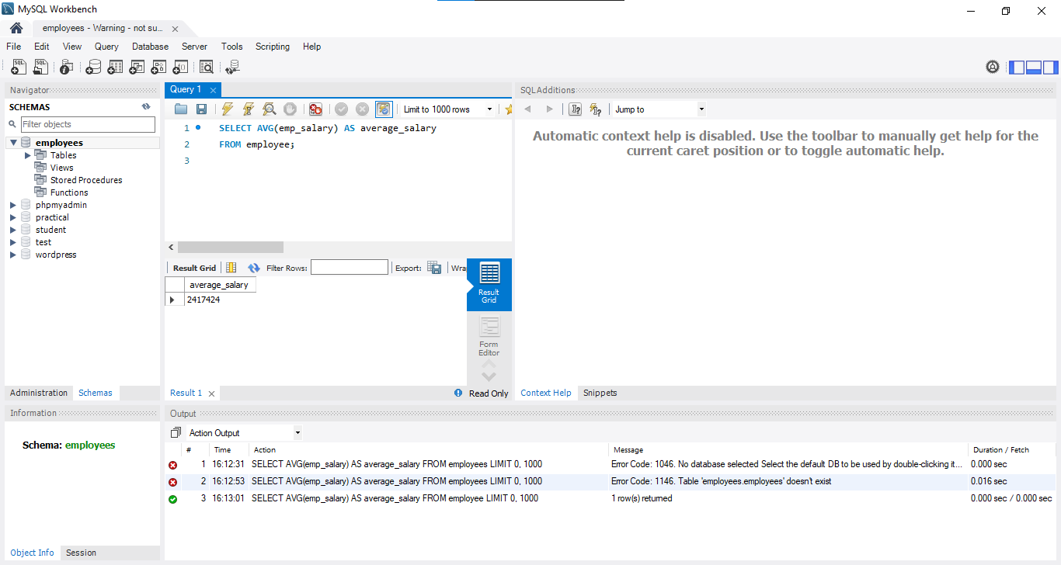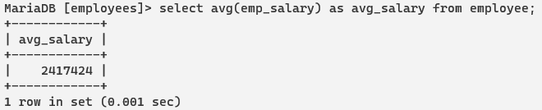

**5. Conclusion**

In conclusion, our laboratory work on SQL has been an invaluable experience in gaining hands-on expertise in managing and querying relational databases. Through a series of practical exercises and experiments, we have not only learned the fundamentals of SQL, including data retrieval, manipulation, and database administration but also developed a deeper appreciation for the pivotal role SQL plays in modern data-driven applications. This laboratory work has equipped us with essential skills that are highly relevant in today's data-centric world, and it serves as a solid foundation for future endeavors in database management and application development.

Page: 15